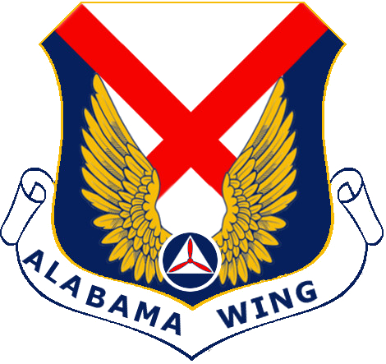
Certificate Of Appreciation

Presented In Recognition Of

Guest Speaker Name Here

Honorary Guest Speaker

At The Graduation Ceremony Of The
Cadet Great Start Program - 23 March 2020
Mobile Composite Squadron Of The Civil Air Patrol
 | 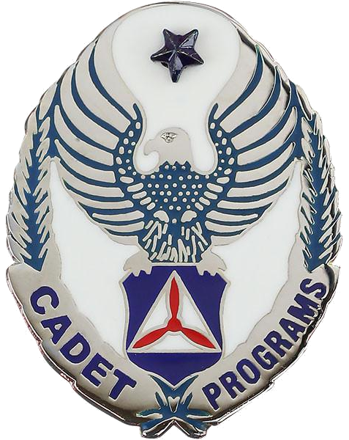
Squadron Commander |  | Deputy Commander For Cadets

