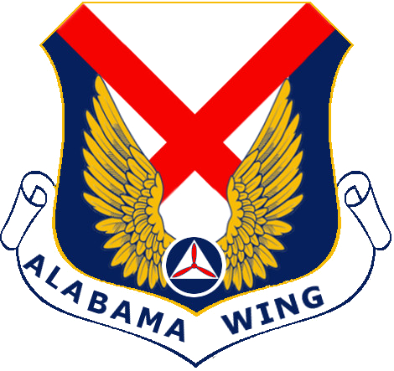
Certificate Of Achievement
Presented To
Cadet Name Here
For Successful Completion Of The
Cadet Great Start Program - Spring 2020
And Being Promoted To The Grade Of
Cadet Airman
Given This 00th Day Of April 2020
 | 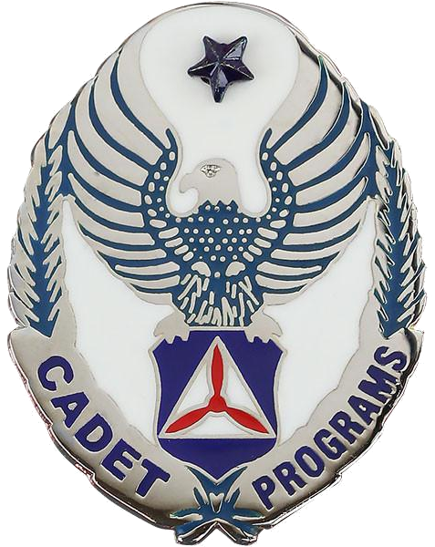
Squadron Commander |  | Deputy Commander For Cadets

